**PROPOSED DAM AT MANIBHADRA REGION**

***PURPOSE-***

To control the surplus water from Hirakund dam, there is a need of second dam in the lower delta region of the Mahanadi river basin area. At Manibhadra, NAYAGARDH dist. ,Odisha, a dam should be contructed which will resist the surplus water in Mahanadi river and even this dam will divide the diversion of Mahanadi water towards Andhra Pradesh state to meet with Godavari river and then it will flow into Bay of Bengal.

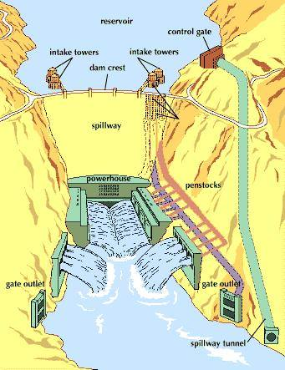

Fig. proposed plan of dam.

***STRUCTURE OF DAM-***

It is proposed to construct an Arch shaped Dam at manibhadra region to resist the surplus water of Mahanadi. As arch shaped dam are quite thin- walled dam and hence lighter in weight as compared to other types of dams.

**1**. A quantum of 12,165 Mcum is proposed for diversion through the link taking off at Manibhadra reservoir on Mahanadi to Dowlaiswaram Barrage on Godavari.

**2**.This link will provide enroute irrigation benefits to the tune of 4.43 lakh hectares, of which 0.91 lakh hectares in Andhra Pradesh and 3.52 lakh hectares in Orissa.

**3.**The total length of the link canal is about 828 km including 6.15 km.of length through a tunnel.

**4**.There is also a provision to generate 445 MW of hydropower at Manibhadra dam in this link canal proposal.

***PROPOSED DETAILS OF DAM AND RESERVOIR*** –

Dam should stands 352 feet (107.29 m) high above its foundations and 228 feet (69.49 m) above the Mahanadi river. It measures 1,285 feet (392 m) long along its crest, with a maximum base thickness of 131 feet (40 m), while its crest thickness is 27 feet (8.2 m). The dam contains about 987,000 cubic yards (755,000 m3) of concrete. The reservoir should reach its maximum elevation of 6,040 feet (1,840 m) , with a maximum surface area of 42,020 acres (170.0 km2). The conservation storage capacity is 3,788,700 acre feet (4.6733 km3),[14] of which 3,515,700 acre·ft (4.3366 km3) is active capacity, useful for release and power generation. During floods the reservoir can go about 5 feet (1.5 m) higher, for a total of 4,003,100 acre feet (4.9378 km3), spreading over 43,820 acres (17,730 ha).

***POWER GENERATION-***

The dam's hydroelectric power plant will be located at its base. It should consists of three 50,650 kilowatt generators, powered by three Francis design turbines of 50,000 horsepower (37,000 kW). The total nameplate generating capacity of the Manibhadra Dam will be 445 megawatt. Three 10-foot (3.0 m) diameter penstocks should feed water to the power plant.

 fig penstock

With the help of this proposed power plant we will be able to generate such a vast amount of electricity which will help in providing electricity to the nearby are at low cost .And this will also help in development of the civilisation in the nearby areas of Manibhadra and nayagardh DIST.



Fig Generater room.

***SPILLWAYS-***

The spillway should consists of a 675-foot (206 m) long tunnel that runs through the left abutment of the dam. Two 16.75-by-34-foot (5.11 m × 10.36 m) gates at the tunnel entrance will pass up to 28,800 cubic feet per second (820 m3/s) of floodwater. At its upstream end the tunnel is 26.5 feet (8.1 m) in diameter, and at the discharge point is 18 feet (5.5 m) in diameter. The dam's outlet works consist of two 72-inch (1.8 m) diameter steel pipes through the dam. The discharge capacity of the outlet works is 4,000 cubic feet per second (110 m3/s).



Fig. spillway tunnel

***DESILTING CHAMBER-***

Mahanadi river carries heavy sediment load in suspension or as bed load. The suspended load, especially the sharp edge fine sand transported by river in HIRAKUND DAM , which caused wear of turbine runner blades , and silting of dam , results in decrease in reservoir capacity of Hirakund dam.

Therefore it is necessary to provide necessary arrangement for exclusion of sediments from water before entering into reservoir. Normally sediments larger than a particular size(0.2mm) are removed from water entering into turbines. Desilting chambers, also known as silting tanks, settling basins, sediment traps should be used for removing sediments larger than therequired size, which enter into water conductor systems.



Fig. desilting tank.

***ENVIRONMENTAL ISSUE:***

The Manibhadra reservoir will submerge a total area of 63,003 ha at FRL 86.0 m. Under this reservoir, forest area to the extent of 9,520 ha is likely to be submerged. About 79,000 persons will be affected by the proposed Manibhadra reservoir submergence.